UPI Delay Detection

CASE STUDY
Using GRU-Based Deep Learning to Identify Stuck Payments

UPI Delay Detection tests whether recent bank-health data can flag a UPI payment that is likely to get stuck. It uses a Gated Recurrent Unit (GRU) trained on 450,000 simulated transactions. On held-out days, the model placed 27% of all stuck payments in its top 1% of risk scores, but a gradient boosting baseline scored slightly higher on PR-AUC, so the results do not show that the GRU is the better choice.

Case Background and Motivation
A rent payment of mine once took about 58 hours to resolve. For most of that time the app showed neither success nor failure, so there was no way to tell whether to wait, retry or call the bank. I use the word "unresolved" for that state. It is my own label, not an official UPI status.
The delay made me curious about a narrower question than "why did this happen". If a bank is struggling, with slow responses and rising timeouts, does that show up in the data before a payment gets stuck? If it does, a system could in principle flag risky payments early.
This project cannot explain my own payment. It’d just a controlled experiment on the general idea, and it uses no live UPI, bank, Google Pay or NPCI data.

Methodology
Real transaction outcomes and internal bank telemetry are not publicly available, so I built a simulator. It produced 450,000 transactions across 70 simulated days and eight anonymized banks. Each transaction came with a stuck/not-stuck label, a resolution time, and the telemetry of the two banks involved: latency, timeout rate and resource utilization. Because the simulator generates the labels, the experiment can only show whether patterns inside that simulated world are learnable.
For each transaction, the model sees the ten most recent telemetry readings, taken three minutes apart and ordered from oldest to newest. Each reading has six values: the three signals for the beneficiary bank and the same three for the remitter bank. That gives a (10, 6) sequence, which is paired with 22 static features such as bank identity and transaction details.
The data were split by time rather than at random, so the model is always tested on days it has not seen:
Split | Days | Transactions
Training | 0 to 48 | 313,108
Validation | 49 to 58 | 62,258
Test | 59 to 69 | 74,634
Scalers were fitted on the training data only. Validation data was used to decide when to stop training, and the test set was used once, at the end.
Stuck payments are rare, so accuracy is not a useful measure: a model that always predicts "not stuck" would be right more than 99% of the time. The main metrics were PR-AUC and ROC-AUC, plus the precision and recall among the 1% of transactions the model scored as riskiest. I compared the GRU against logistic regression without telemetry, logistic regression with telemetry, gradient boosting and a multi-task MLP.

GRU Model Design
A GRU is a recurrent neural network. It reads a sequence one step at a time and keeps a hidden state that summarizes what it has seen so far. Here that means it reads the ten telemetry readings in order, so it can use the trend (for example, latency rising over the last half hour) instead of treating each reading as an unrelated input.
I chose a GRU because the input is a short time series, not just a collection of independent measurements. Its update and reset gates help retain useful information from earlier readings while updating the representation as new telemetry arrives. This makes it a suitable, relatively lightweight recurrent model for testing whether recent trends matter.
The final hidden state is combined with the 22 static features and passed through a dense classifier, which outputs a risk score for each transaction.
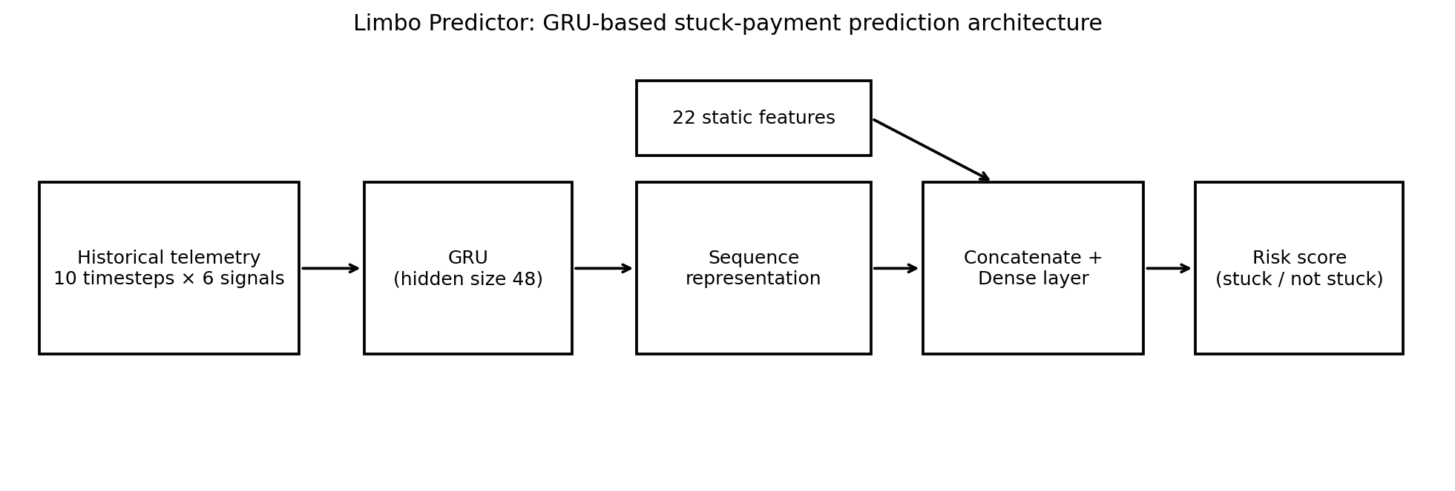
Figure 1. GRU architecture for stuck-payment (limbo) risk prediction.
Training used weighted binary cross-entropy to handle the class imbalance, the AdamW optimiser, and early stopping based on validation PR-AUC. The model was written in PyTorch and trained on a CPU.

Results and Findings
The test set had 74,634 transactions, and 468 of them (0.63%) were stuck. The GRU reached a PR-AUC of 0.1611 and a ROC-AUC of 0.7206.
The top 1% of risk scores is the easiest way to see what that means in practice. In that group, 17.16% of transactions were stuck, against a base rate of 0.63%, which is a lift of about 27 times. The group contained 27.35% of all stuck transactions in the test set. Figure 2 visualises this concentration. In practical terms, reviewing a small, high-scoring subset would surface a disproportionate share of stuck cases in this simulation, although most transactions in that subset would still not be stuck.
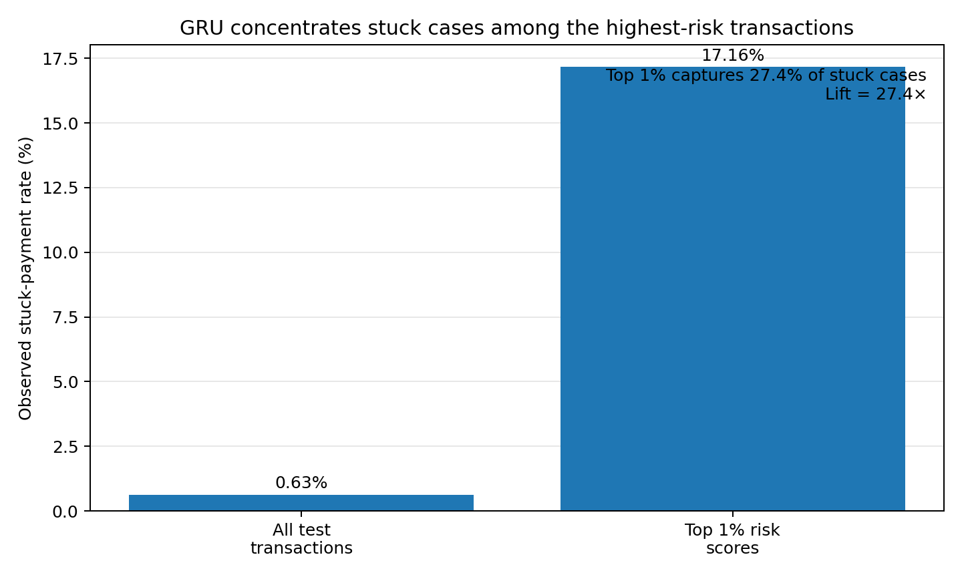
Figure 2. Stuck-payment concentration in the highest-risk 1% of predictions.
Validation PR-AUC peaked at 0.2908 at epoch 7, which is well above the test result. The stuck rate also fell between the two periods, from 1.31% in validation to 0.63% in testing, which points to a shift in the simulated data over time. A good validation score therefore does not guarantee the same performance on later days. The training curve is shown in Figure 3.
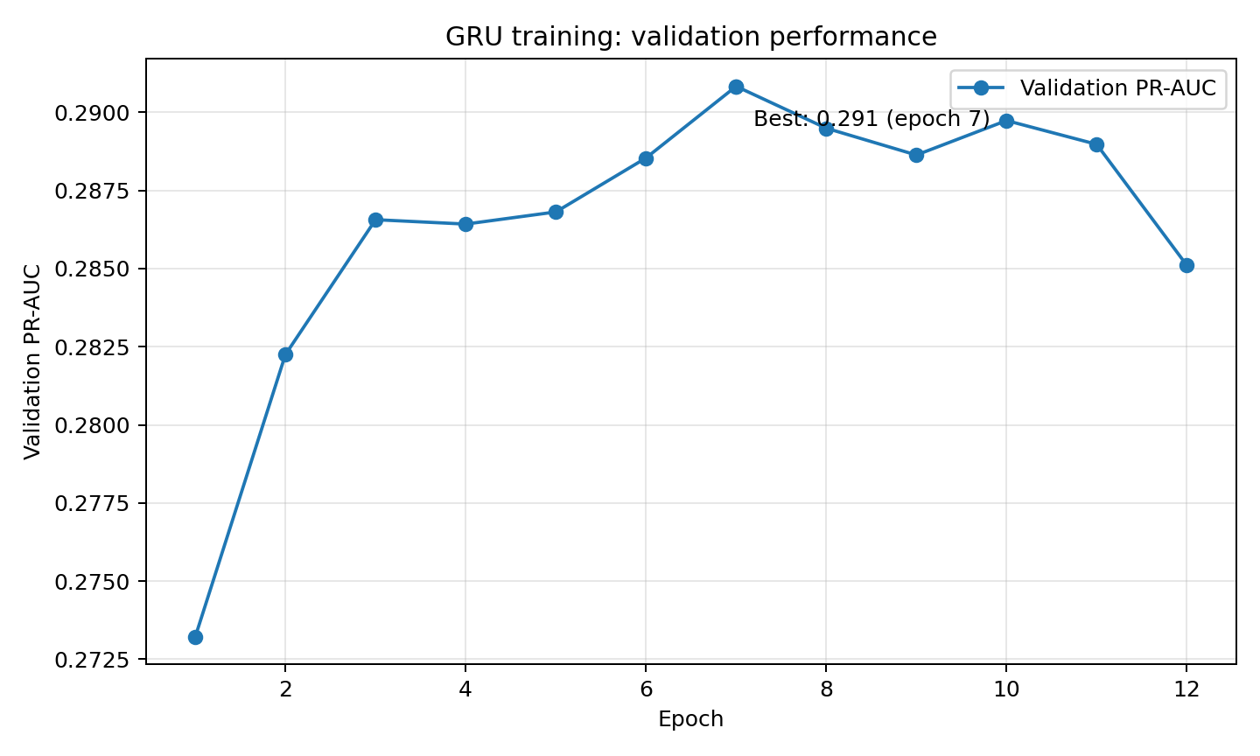
Figure 3. Validation PR-AUC across GRU training epochs.
The precision-recall and ROC curves on the test set show the same picture: better than chance, but far from a clean separation. These are shown in Figures 4 and 5, respectively.
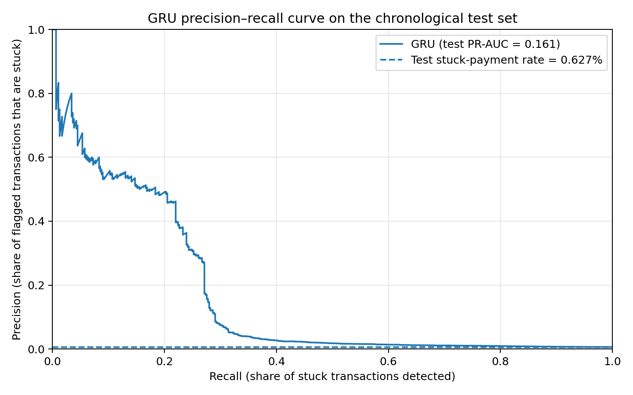
Figure 4. GRU precision-recall curve on the chronological test set.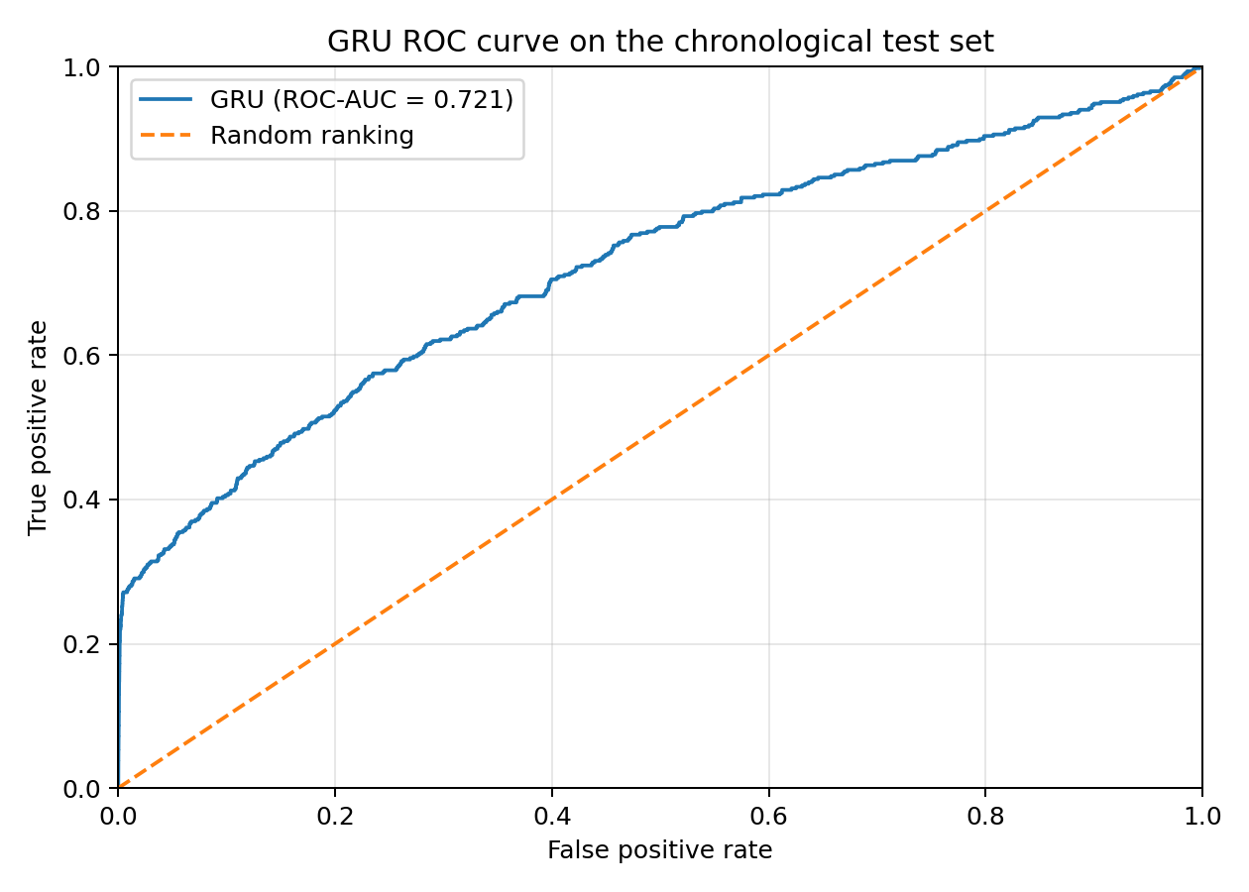
Figure 5. GRU ROC curve on the chronological test set.

Comparison with Baseline Models
Model | Test PR-AUC | Test ROC-AUC
Logistic regression + telemetry | 0.1575 | 0.689
Gradient boosting | 0.1627 | 0.718
Multi-task MLP | 0.1480 | 0.696
GRU | 0.1611 | 0.7206
Gradient boosting had the highest PR-AUC and the GRU had the highest ROC-AUC. The differences are small, so this experiment does not show that the GRU is better. What it does show is that, in this simulated setting, a model that reads the telemetry as a sequence performs about as well as the other models. Its PR-AUC of 0.1627 was 0.0016 higher than the GRU's 0.1611. The GRU should therefore be described as competitive, not best-performing.
The risk scores also overlap. Stuck and non-stuck transactions both receive a wide range of scores, so a high score means a higher estimated risk, not a certain failure. Figure 6 shows this overlap.
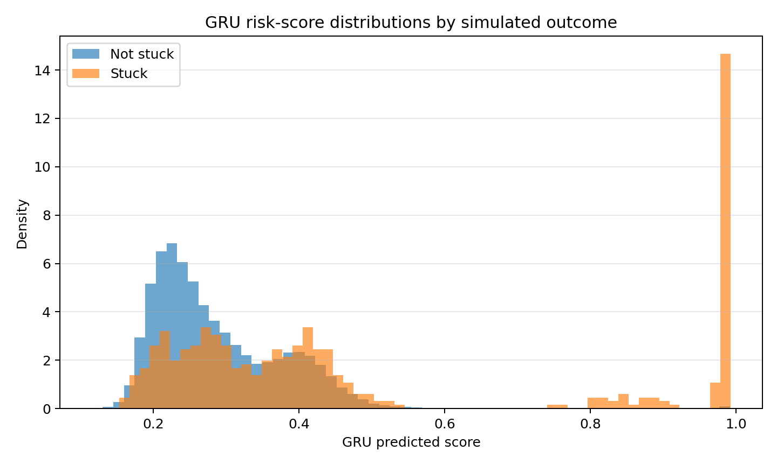
Figure 6. GRU risk-score distributions for simulated stuck and non-stuck transactions.

Limitations
The data and labels are synthetic, so every result depends on how the simulator was designed and says nothing about real UPI performance. The test set has only 468 stuck cases, which limits how much can be said about rare outcomes. The model also cannot say why a real payment was delayed, including mine. The top-1% view shows how well the model concentrates stuck cases, but it does not remove false alarms.
If something like this were used on a real system, the score could help decide which transactions to monitor. That would require authorized real telemetry, verified outcomes, privacy safeguards, calibration checks, and testing on future time periods. A high score should never be read as confirmation that a payment has failed.

Conclusion
The GRU picked up a usable signal from short histories of bank telemetry and ranked stuck payments well enough to concentrate more than a quarter of them in the top 1% of scores. It did not beat gradient boosting, and the validation-to-test drop shows how easily a promising number can fail to carry over to later data.
The next steps are to train with several random seeds, try different sequence lengths, improve calibration, and test on anonymized real data if access ever becomes available.

Appendix: Source Code and Reproducibility
• sim.py: Generates the synthetic bank environment, telemetry and transactions.
• gru_experiment.py: Builds sequences, trains the GRU and evaluates its predictions.
• run_experiments.py: Runs the baseline experiments and produces comparative results.
• mtl_mlp.py: Implements the multi-task MLP baseline.
• requirements.txt: Lists the Python packages required to run the project.

